**Jenkins**

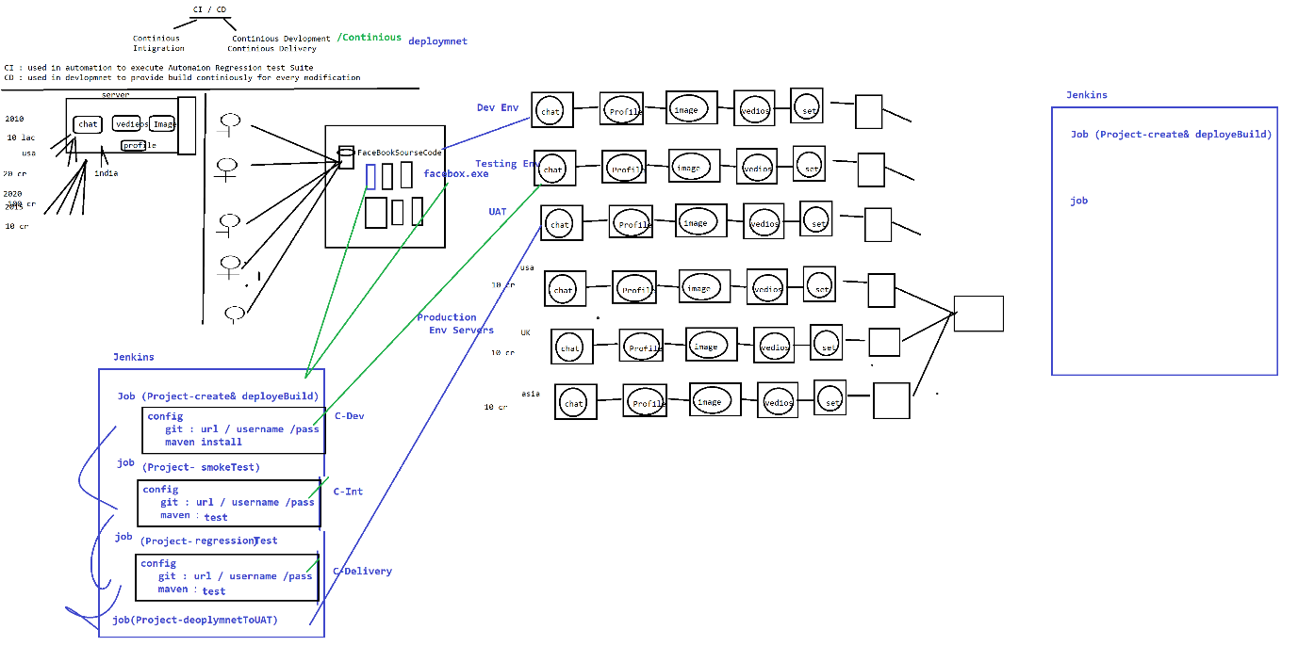

1. **Installation Steps :**
2. Download Jenkins & install
3. Login to Jenkins & install below Plugin

Jenkins 🡺 Manager Jenkins 🡺 Manage Plugin🡺 Select “Available”

Search & install below Plugins

. Maven Integration Plugin

GitHub Integration Plugin

1. Configure Env variables in Jenkins for below PlatForm/Software

. JDK : C:\Program Files\Java\jdk1.8.0_161

. Maven : D:\apache-maven-3.5.2-bin\apache-maven-3.5.2

.Git : C:\Program Files\Git\bin\git.exe

Jenkins 🡺 Manager Jenkins🡺 Global tool Configuration

1. What is Jenkins:

Its CI/CD/CD tools

Continuous Development: which includes build creation & deployment processes is automated using Jenkins

Continuous Integration: execution of smoke & regression testing process is automated using Jenkins

Continuous Delivery : delivery final stable build to UAT environment , this process is automated using Jenkins

1. What is use of Jenkins in Testing

Jenkins is a Continuous integration tool where continuously monitor the framework Build in git location, then perform appropriate action based on request

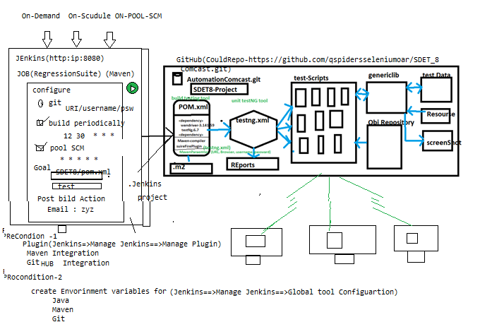

Advantages of Jenkins

1. Jenkins Provide 3 level of execution

. On demand : based on Customer demand we can start the execution

. On Scheduling: based on scheduled time , start the execution automatically

. POOL SCM : where continuously monitor the SCM(GitHub) & automatically start the execution whenever we get new Build / one new test script is getting added to Git

1. Email Notification :

. Jenkins sends out an execution Report via email, once execution is completed

. Jenkins also Send Build broken Email, when Compilation issue between the framework component

1. Jenkins also support run time **parameter**
2. **Jenkins also support PipleLines Job**

**What is Jenkins Pipeline?**

Execute multiple job sequentially one after the other I called Jenkins Pipeline

Note : make sure “pipeline” plugin should be installed in jenkins

EG : below example is the list job’s re pipelined , & it mean just execute 1 st job then automatically all the jobs executed which is available in pipeline.

Job 1 -Build creation 🡺Job2- Build-Deploye🡺Job3-SmokeTest🡺Job4-Regressiontest🡺job4-Delivery;

**How to Set Jenkins parameter?**

Jenkins parameter help us to pass data in to test suite in run Time

